Lab 7 Report
Content
1. Download Istio 1
2. Install Istio 1
3. Install the Kubernetes Gateway API CRDs 1
4. Deploy the sample application 2
5. Open the application to outside traffic 2
6. Access the application 3
7. View the dashboard 3

1. Download Istio
Go to the Istio release page to download the installation file for the OS, here we choose istio-1.28.1-win-amd64.zip.
In the "System Variables" section, locate "Path" and add the full path of the bin directory of Istio.
Start minikube and verify installation.

2. Install Istio
Install Istio using the demo profile, without any gateways:
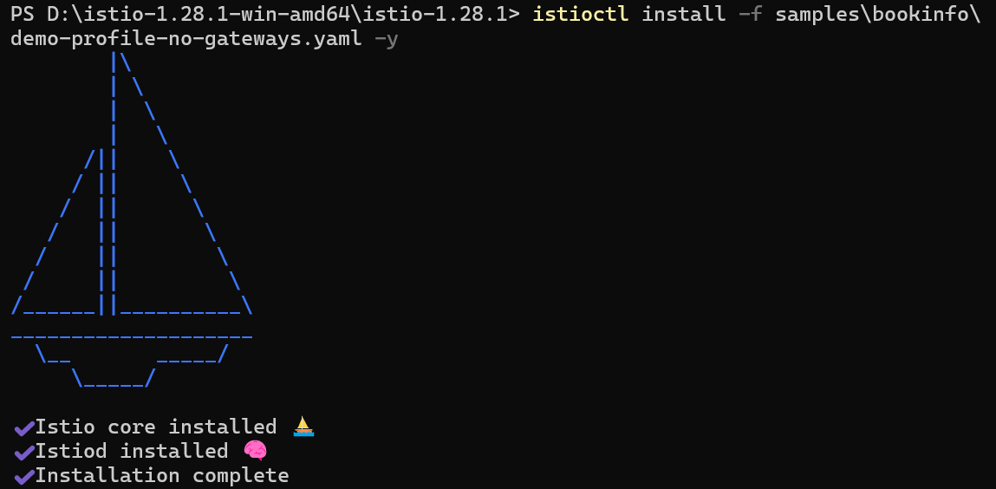
Add a namespace label to instruct Istio to automatically inject Envoy sidecar proxies when we deploy our application later:

3. Install the Kubernetes Gateway API CRDs
Install the Gateway API CRDs, if they are not already present:
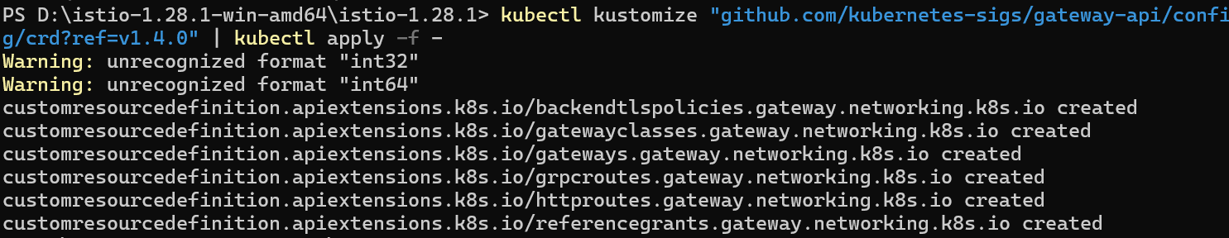

4. Deploy the sample application
Deploy the Bookinfo sample application:
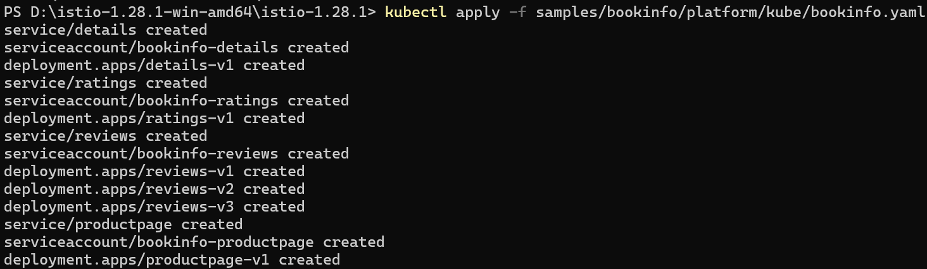
The application will start. As each pod becomes ready, the Istio sidecar will be deployed along with it.
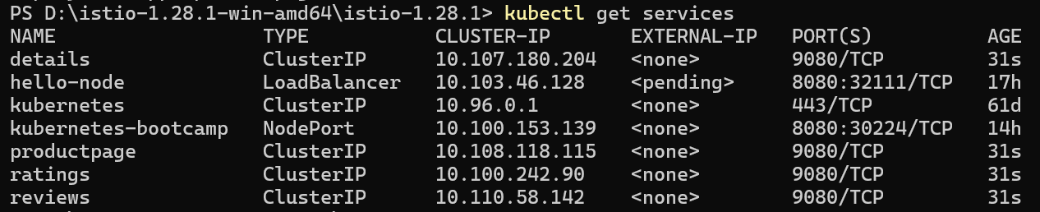
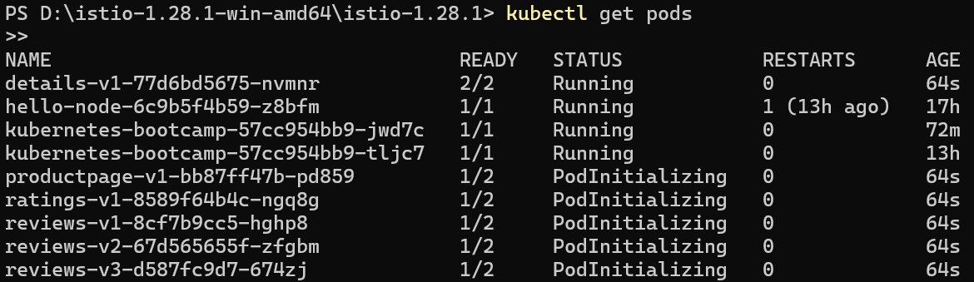
Validate that the app is running inside the cluster by checking for the page title in the response:

5. Open the application to outside traffic
Create a Kubernetes Gateway for the Bookinfo application:
Change the service type to ClusterIP by annotating the gateway and check the status of the gateway.
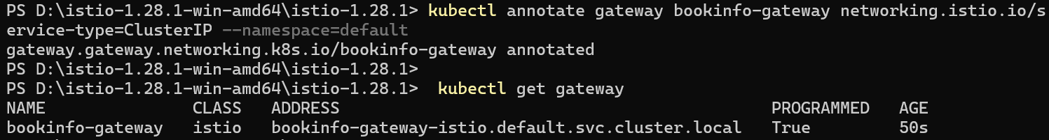

6. Access the application
We will connect to the Bookinfo productpage service through the gateway we just provisioned. To access the gateway, we need to use the kubectl port-forward command:
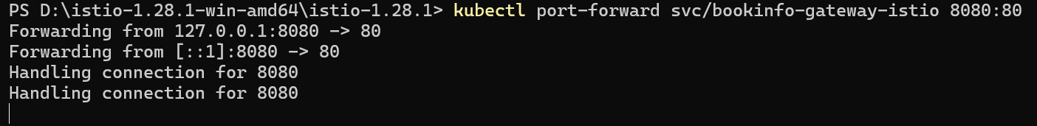
Open the browser and navigate to http://localhost:8080/productpage to view the Bookinfo application.
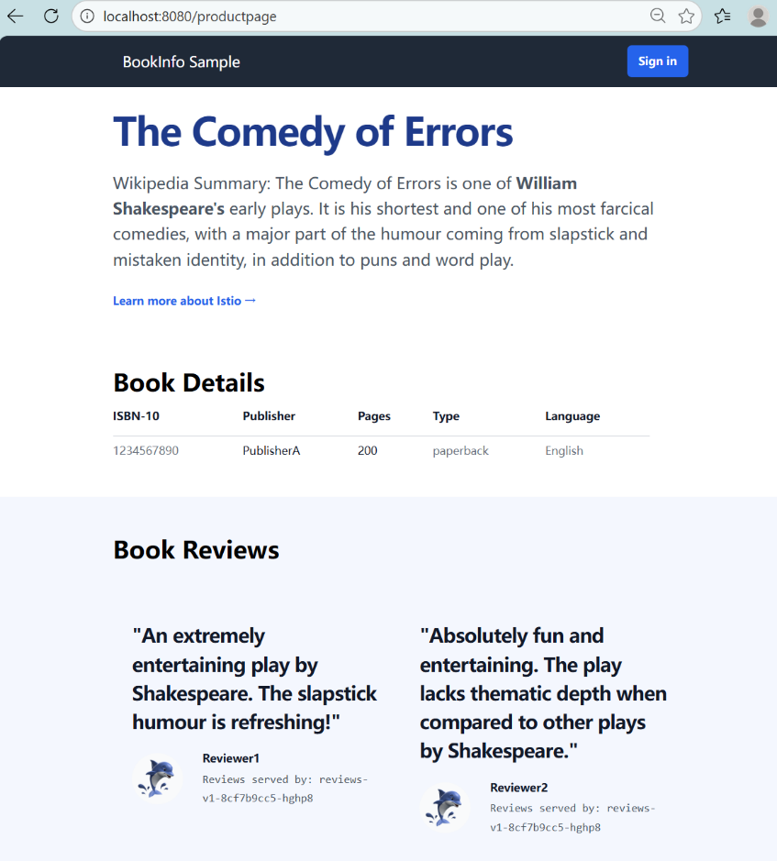

7. View the dashboard
Install Kiali and the other addons and wait for them to be deployed.
Access the Kiali dashboard.
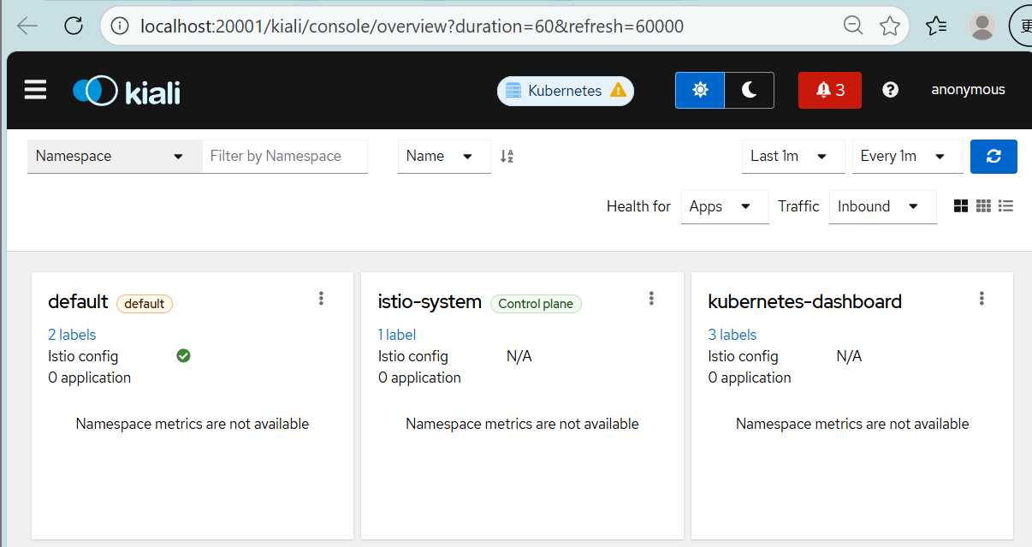
The Kiali dashboard shows an overview of our mesh with the relationships between the services in the Bookinfo sample application.
